**Hamilton 2022 - 2023 Supply Lists /Listas de suministros**



|  |  |  |  |
| --- | --- | --- | --- |
| **Prekinder**   * 1 colchoneta roja y azul y manta pequeña * 3 caja Kleenex * 1 caja de toallitas para bebe * 1 mochila * 2 refrigerios no perecederos para 20 estudiantes * Protector solar * Botella de agua | **Kindergarten**   * 1 mochila * 2 paquetes de   Ticonderoga My First  Pencils   * 1 contenedor de toallitas Clorox * 1 lata de desinfectante Lysol * 3 cajas de Kleenex * Protector solar * Botella de agua * Aperitivos por la tarde   (todos los día) | **Grado 1 y 2**   * 1 mochila * 1 contenedor de   toallitas Clorox   * 2 rollos de toallas de papel * lápices * 3 cajas de Kleenex * 1 botella de   desinfectante de  manos   * Protector solar * Botella de agua * Aperitivos por la tarde   (todos los días) | **Grado 3,4,5**   * 1 mochila * 1 rollo de toallas de   papel   * 3 cajas Kleenex * lápices * 1 paquete de toallitas   Clorox   * 1 botella de desinfectante para   manos   * 1 paquete de papel cuadriculado * Protector solar * Botella de agua * Aperitivos por la tarde   (todos los días) |

|  |  |  |  |
| --- | --- | --- | --- |
| **Prekindergarten**   * 1 Red and blue sleeping mat & small blanket * 3 Box Kleenex * 1 Box Baby Wipes * 1 backpack * 2 Non-Perishable Snacks for 20 students * Sunscreen * Water Bottle | **Kindergarten**   * 1 backpack * 2 packages Ticonderoga My First Pencils * 1 container Clorox wipes * 1 can Lysol disinfectant * 3 boxes of Kleenex * Sunscreen * Water Bottle * Afternoon Snacks   (daily) | **1st, 2nd Grade**   * 1 backpack * 1 container Clorox wipes * 2 rolls of paper towels * Pencils * 3 boxes of Kleenex * 1 bottle of hand sanitizer * Sunscreen * Water Bottle * Afternoon Snacks   (daily) | **3rd, 4th, 5th Grade**   * 1 backpack * 1 roll paper towels * 3 boxes Kleenex * Pencils * 1 package Clorox wipes * 1 bottle hand sanitizer * 1 package graph paper * Sunscreen * Water Bottle * Afternoon Snacks   (daily) |

Hamilton Elementary 22-23



School Uniform Expectations Expectativas uniformes escolares

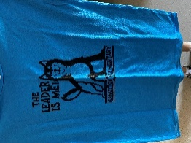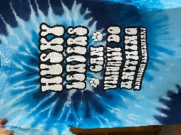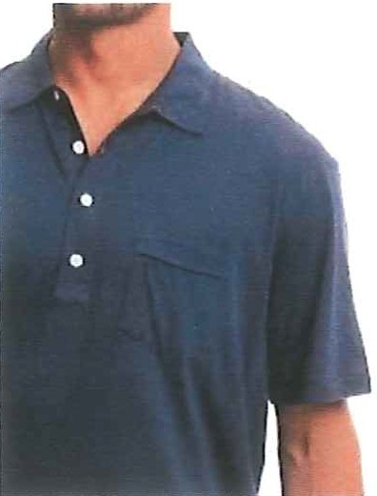POLO SHIRTS or Hamilton Shirt

* white, navy, royal blue, or light blue

UNIFORM PANTS OR SKIRTS

* Khaki, navy, or black pants, shorts,
* dresses, skirts or jumpers
* or jeans with NO HOLES

ATHLETIC SHOES

* velcro or tie

POLOS o Camiseta de Hamilton

* blanco, azul marino, azul real o azul claro

PANTALONES O FALDAS UNIFORMES

* Caqui, azul marino o negro o vaqueros sin agujeros

ZAPATOS ATLÉTICOS

* velcro o corbata